Book 1
Additional Scenarios for the Game

CRY HAVOC

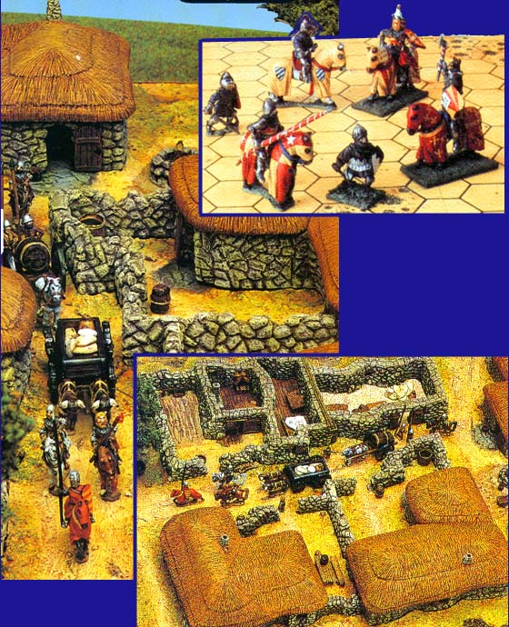
*The Battle of Little Wooton
*The Foraging Party * The Knight Errant
*The Knight’s Lady *The Rescue
*Reconnaissance Patrol

Contents

How to use this booklet Page 1
The Knight Errant (Scenario 0ne) Page 1
The Foraging Party (Scenario Two) Page 3
The Knights Lady (Scenario Three) Page 5
Reconnaissance Patrol (Scenario Four) Page 8
The Rescue (Scenario Five) Page 9
The Battle of Little Wootton (Scenario Six) Page 11

How to use this Booklet

The scenarios described in this booklet have been designed in order to expand the Cry Havoc game; you will need the Cry Havoc game to play these scenarios.

Entering the map

Characters must pay movement cost for the entry hex. Note that half-hexes are playable; movement point cost for half-hexes is the same as that for whole hexes.

THE KNIGHT ERRANT (Scenario One)

Map Layout: Crossroads and Village

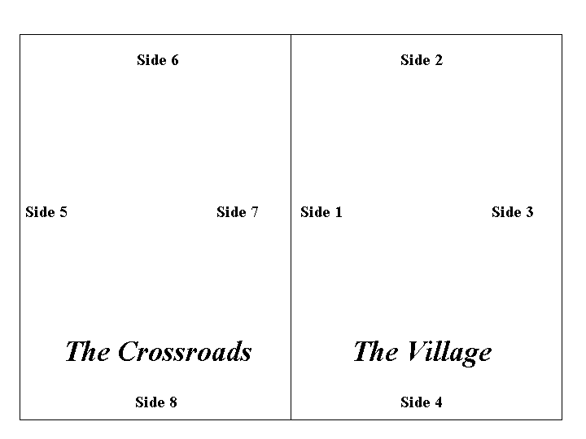
Approx. time to play 1 and a half to 2 hours.

Setting the Scene

A Company of mercenary soldiers has been terrorizing the village, threatening its inhabitants with dire punishments if they do not pay them in both money and kind. A wandering knight, Sir Richard, has encouraged the village to stand up to the extortionist, and they have defied the mercenaries. Arnim, the leader of the mercenary band, has decided to teach the village a lesson.

The Sides

Sir Richard

Dismounted Knights Horses Peasants Civilians
Sir Richard Sir Richard Baker Audrey
Sir Gunter Sir Gunter Cedric Edith
Carpenter
Farmer
Gam
Giles
Gobin
Radult
Salter
Smith
Wulf

The Mercenaries
Sergeants Halberds Spears
Arnim Frederick Bertin
A’Wood Tom Crispin
Watkin Hal
Wynken Odo
Perkin

Starting Positions
- The ‘Sir Richard’ player sets up first, placing his characters as follows:
  - Giles and Farmer on guard near Side 6 of The Crossroads.
  - Cedric on guard on the Hillock.
  - Edith and Audrey at the Pond.
  - All others in the village.
- Cedric gives the alert as the mercenaries approach the village. The ‘Sir Richard’ player may move Cedric (and only Cedric) up to 6 movement points before the game turn 1.
- The ‘Mercenaries’ player takes his turn first, and the mercenaries enter the map from side 5 on turn 1.

Special Rules

The ‘Sir Richard’ player always subtracts one from the die roll when Sir Richard’s playing piece attacks (either on his own or with other characters); treat a ‘0’ as a ‘1’ result. Similarly, if Sir Richard’s playing piece is attacked, the attackers add one to their die roll; treat ‘11’ as a ‘10’.

Victory Conditions.

Play continues until one of three results occur:
- Sir Richard is killed – the Mercenary player wins.
- Six of the ‘Sir Richard’ player’s characters (excluding Sir Richard) are killed - the Mercenary player wins.
- Five mercenaries are killed – the ‘Sir Richard’ player wins.

THE FORAGING PARTY (Scenario Two)

Map Layout: Only the Crossroads map is used.
Approx. time to play: Three quarters of an hour.

Setting the Scene

Sometimes it is not possible for horses to be fed entirely from stores and supply wagons. Then the horses have to be taken to suitable pastures, and they must be guarded from the enemy while they graze.

The Sides

The Foragers
Mounted Knights | Sergeants | Peasants
Sir Alain | Arnim | Cedric
Sir Jaques |  | Gam
 |  | Gobin
Horses only | Spears | Radult
Sir Conrad | Ben | Salter
Sir Gaston | Bertin | Smith
Sir Piers | Crispin
Sir Richard | Hal
Sir Roger | Odo
 | Wat

The Attackers

Mounted Knights

Sir Gunter

Sir James

Sir John

Sir Peter

Sir Thomas

Sir William

Starting Positions
- The Forager player sets up first. All the horses (excluding the mounted knights) must be placed in clear terrain. Each peasant must be adjacent to one horse only. This will make 6 pairs of horse plus peasant. These pairs must not be adjacent to any other character or horse. The other characters in the foraging party may be set up anywhere on the map.
- The attackers enter any one side of the map on turn one.
- The attacker takes his phase first.

Special Rules
  - Capturing Horses
    - A mounted knight may attempt to catch one adjacent rider-less horse instead of engaging in combat (i.e. during step 5) in the controlling player’s phase. The player rolls the dice and the knight succeeds on 1-8. Only one attempt per knight may be made each turn.
    - If a mounted knight succeeds in catching a rider-less horse, it can be led by him; continue to move the mounted knight as normal (i.e. up to 8 movement points) treating the horse as an extension of the character counter.
    - If a mounted knight engages in combat or is attacked, he will automatically release any caught horse, and the horse must be caught again if the knight wishes to move it.
    - Captured horses may be strung together in the same way as pack mules (see page 9 of Cry Havoc ‘Rules of Play’), but only dismounted characters may attach/detach horses to/from a string of horses.
    - Note that a dismounted character can catch an adjacent rider-less horse automatically during the movement step, unless an enemy character is adjacent to it.
  - For combat against rider-less horses, roll dice for “combat against mounted opponents”, but treat as “no effect” results A,B,C,E,G; also of course ignore effects on riders.
  - Characters of both sides may exit the map with or without rider-less horses. Characters who leave the map may not return.
Victory Conditions.
The attackers scores victory points as follows:
- For each horse captured (escorted off the map in any direction) 10 points
- For each horse killed (including those of defending knights) 5 points
- For each enemy knight killed 15 points
- For each enemy peasant killed 1 point
- For each other enemy character killed 4 points
The defender scores victory points as follows:
- For each attacker’s horse killed or captured 10 points
- For each enemy knight killed 15 points

When all the attacking characters have left the map (or been killed), total each side’s victory points and subtract the smaller total from the larger.

The following table gives the scale of victory for the side with the larger total:
0 points = draw
1-10 points = marginal victory
11-20 points = substantial victory
21+ points = decisive victory

THE KNIGHTS LADY (Scenario Three)

Map Layout: Only the Village map is used.
Approx. time to play: 1 hour.

Setting the Scene

Edith, wife of Sir Richard, is traveling to the coast to meet her husband, who is returning from the Crusades. As these are trouble times, she takes a bodyguard with her. Troubles do indeed befall her on her journey, for as she stops at a village for the evening, a band of cutthroats attempt to capture her so that they can hold her for ransom.

The Sides

The Bodyguard
Civilians | Sergeant | Shortbow
Edith | Martin | Aylward

Audrey (maid)
Dismounted Knight | Spears
Sir Piers | Mark
Horse | Bertin

Sir Piers

The Merchant’s Party
Civilians | Mules | Bills
Leopold the Merchant | Mule 1,2,3 | Guy
Philip his assistant |  | Jean
 |  | Rees

The Cutthroats
Sergeant | Halberds | Crossbows
Arnim | Ben | Forester
 | Frederick
 | Geoffrey
 | Naymes
 | Otto
 | Tiom

Local Peasants
Baker | Carpenter | Farmer
Giles | Salter

Starting Positions
- The Merchant’s Party set up in building 3 and building 3 courtyard.
- The local peasants set up in building 1, 2 and 4.
- The Bodyguard player then sets up his characters. Edith and Audrey must be place in one of the rooms in Building 5. The other members of the bodyguard may be set up anywhere on the village map, except in the same room as Edith and Audrey (doorway hex does not count as in the room). Sir Piers’ horse must be in the courtyard of Building 5; Sir Piers may not be in the courtyard.
- The Cutthroat player then moves his characters up to 4 movement points onto the map from any side or sides, but may not end this move adjacent to any other non-Cutthroat character.
- Then normal play starts; the cutthroat’s player takes his turn first, (i.e. the cutthroat player get to move again.

Special Rules
- At the of the bodyguard player’s turn in turn 2 (only), the bodyguard player rolls dice to find out if the merchant’s party or local peasants join the bodyguard against the cutthroats.

Roll one die for each group.
- Merchant’s Party:
  - 1-3 no effect; Merchant’s Party will not move, unless any member of the party is attacked by the cutthroats (in which case the party joins the bodyguard).
  - 4-10 join the bodyguard; the Merchant’s Party characters are controlled by the bodyguard player for the rest of the game.
- Local Peasants:
  - 1-6 no effect (see Merchant’s Party above).
  - 7-10 join the bodyguard; local peasants characters are controlled by the bodyguard player for the rest of the game.
- No Bodyguard or Cutthroats character ay move through a hex occupied by a Merchant’s Party or Local Peasant character, unless these “neutral” characters join the bodyguard side. In this case they are treated as Bodyguard characters.
- Edith will surrender if she is adjacent to a cutthroat character who is not also adjacent to a bodyguard character (excluding Audrey). If Edith has surrendered, she can be moved by the Cutthroat player as an extension of any Cutthroat playing piece. She may be passed from one character to another, but note that her movement allowance is only 4. If at any time the cutthroat player does not have a character adjacent to Edith after she has surrendered, the bodyguard player can immediately move her playing piece up to 4 movement points, subject to the usual movement restrictions. If Edith escapes, the cutthroat player may attempt to force her to surrender again.
- Combat through windows: Combat is allowed through window hexsides. Characters in window hexes (i.e. House interior hexes containing windows) are treated advantage “+”.
- The scenario ends when Edith has exited the map (Either captured by the cutthroats or moved by the body guard player), or when the cutthroat player concedes defeat.

Victory Conditions.
The Cutthroats score victory points as follows:
- For capturing Edith and escorting her off the map: 4 points.
- If the Merchant’s Party joins the Bodyguard, 1 extra point for capturing Edith.
- If the Local Peasants join the Bodyguard, 1 extra point for capturing Edith.
- If both the Merchant’s Party and the Local Peasants join the Bodyguard, 2 extra points for capturing Edith instead of 2 and 3 above.
The player with the most victory points at the end of the scenario wins. If players have equal points, the result is a draw.

RECONNAISSANCE PATROL (Scenario Four)

Map Layout: Only the Crossroads map is used.
Approx. time to play: Three-quarters of an hour.

Setting the Scene
A patrol from the army of the King of France seeks the English forces. If the patrol can reach a hillock overlooking a neighboring valley, the King will be able to determine their position, so that his army can defeat then the next day.

The Sides

The English
Party 1 | Party 2 | Party 3
Spearmen | Mounted Knights | Mounted Knights
Ben | Sir Thomas | Sir John
Hal | Sir William | Sir Roger
Mark | Short Bows | Short Bows
Wat | Bowyer | Aylward
 | Fletcher | Matthias
 | Peasants | Peasants
 | Baker | Giles
 | Carpenter | Smith
 | Farmer | Wulf
 | Gam

The French
Mounted Knights | Crossbows | Peasants
Sir Alain | Bertrand | Cedric
Sir Jaques | Gaston | Gobin
 |  | Rodult
 |  | Salter

Starting Positions
- The English player sets up Party 1 first. These characters may be placed anywhere on the map.
- The French player enters the map from Side 6 on turn 1 with all his characters.
- On turn 5 English Party 2 enters the map from side 8.
- On turn 6 and at the start of the English player’s turns thereafter, the English player rolls the die; if 7, 8, 9 or 10 is scored, Party 3 enters from side 8.
- The French player takes his phase first.

Special Rules: None

Victory Conditions. The French must get a knight onto any hex between the Hillock and Side 8; a knight must then exit the map by side 6 or 7. The English win by avoiding a French victory.

THE RESCUE (Scenario Five)

Map Layout: The Village and The Crossroads maps.
Approx. time to play: 2 and a half to 3 hours.

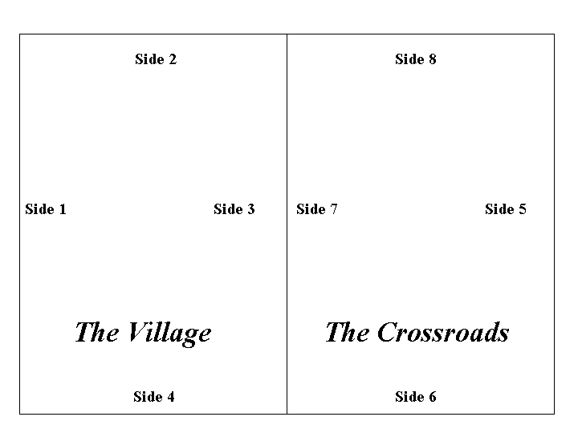

Setting the Scene
Sir Richard’s small group has been cut off from friendly territory during a raid. As the enemy closes in, a force of knights attempts to rescue him.

The Sides

Sir Richard’s Party
Dismounted Knights | Sergeants | Spears
Sir Richard | Arnim | Ben
Sir Piers | Martin | Bertin
 |  | Crispin
 |  | Hal
 |  | Mark
 |  | Odo
 |  | Perkin
 |  | Wat

The Rescuers
Mounted Knights | Sir Peter
Sir Clugney | Sir Roger
Sir Gilbert | Sir Roland
Sir Jaques | Sir Thomas

Sir John

The Attacker

Party 1
Sergeants | Halberds | Bills
A’Wood | Ben | Guys
Tyler | Frederick | Jean
 | Geoffrey | Rees
 | Hubert | Robin
 | Wynken | Tybalt

Party 2

Mounted Knights

Sir Alain

Sir Conrad

Sir Gaston

Sir Gunter

Sir James

Sir William

Starting Positions
- Before turn 1 the defender moves Sir Richard’s Party one normal move onto the map from side1.
- Then the defender takes his first turn (i.e. moves again).
- On turn 1 Attacker’s Party 1 enters the map from side 1, and Party 2 enters from Side 5.
- At the start of turn 4 the rescuers enter the map from side 5.
- In each game turn the defender takes his turn first.

Special Rules: None

Victory Conditions.

The Defender is awarded victory points as follows:
- For each of Sir Richard’s and Sir Piers who exit the map via Side 5: 5 Points.
- For each other character of Sir Richard’s Party who exits the map via Side 5: 1 Point.
- Defending characters may not exit the map via sides other than Side 5.
The Attacker is awarded victory points as follows:
- For each enemy knight killed: 4 points
- For each other enemy character killed: 1 point
The winner is the player with the most victory points when all surviving Defenders have exited the map. If the totals are equal, the result is a draw.

THE BATTLE OF LITTLE WOOTON (Scenario Six)

This scenario is divided into two parts, each of which takes place on one day. This means that players can play each half of the scenario on two separate occasions.

Setting the Scene
Two local noble families are constant and fierce rivals. A legal dispute over the village of Little Wooton will be settled in the courts within a few months, but possession of the village will be a vital factor in the case. Each family prepares its forces, to be led by two knights, Sir Richard for one side and Sir Clugney for the other

Part One – THE VILLAGERS CHOOSE
Map Layout: Only the Village map is used.
Approx. time to play: 1 hour.

Setting the Scene
Advance parties from the two little armies reach the area at roughly the same time, and attempt to recruit the local peasantry, while dispersing the enemy.

The Sides

Sir Richard’s Party
Dismounted Knights | Sergeants | Crossbow
Sir James | A’Wood | Forester

The Clugney
Mounted Knights | Sergeant | Shortbow
Sir Gunter | Martin | Bowyer

The Local Peasant
Baker | Giles | Salter
Carpenter | Gobin | Smith
Cedric | Radult | Wulf
Farmer | Gam

Starting Positions

Building 1: Salter
- Building 2: Gam
- Building 3: Gobin and Cedric
- Building 4: Baker and Farmer. Radult in the courtyard and Giles outside the gate in the street.
- Building 5: Wulf, Smith, and Carpenter.

Sequence of Action
- The players roll one die each. The player with the higher roll (re-roll ties) enters the map on turn 1 and takes his phase first in each turn. He may choose to enter from side 2 or 4.
- The other player also enters the map on turn 1. He rolls a die to determine the side of the map from which his pieces enter as follows:

Die Roll | Side
1-4 | 1
5 | 2
7-9 | 3
10 | 4

- Play continues until all one player’s surviving pieces have left the map, or the players agree to halt fighting until the next day (see second half of the scenario).

Special Rules:
- Recruiting the peasants. Players may recruit the peasants to their side. All peasants start as neutrals and may not move or attack until recruited by a player. Only knights or sergeants can recruit the peasants.
  - Procedure. A knight or sergeant may attempt to recruit any peasant or peasants witin 3 hexes. Recruiting is not allowed through walls, windows or doorways. The recruiting knight or sergeant must start the player’s phase within 3 hexes of the peasant(s) to be recruited and may not move nor attack during the phases. At the end of his phase the player rolls one die for each peasant he is attempting to recruit and refers to the following table for the results.

Recruiting Table
Die Roll | Result
1-5 | Recruited
6-9 | No effect
10 | Takes offence
Key
    - Recruited. Peasant is no longer neutral, he joins the recruiting player’s side, and the piece is controlled by the player in the same manner as the pieces with which he began the scenario (but see 2 below).
    - No effect. Peasant remains neutral.
    - Takes Offence. Peasant is no longer neutral, but he joins the non-recruiting player’s side, and the piece is controlled by the non-recruiting player in the same manner as the pieces with which he began the scenario (but see 2 below).
  - If neutral peasant is attacked, he is immediately recruited by the other player (see also 2 below).
  - Pieces may not move through hexes occupied by neutral peasants.

- If there is no enemy knight or sergeant within 6 hexes (including windows, walls and doorways) of an enemy peasant, and the enemy peasant is adjacent to a friendly knight or sergeant, the friendly piece(s) may refrain from attacking the enemy peasant and attempt to persuade him to change his allegiance (N.B. this is instead of attacking the peasant, and in addition he must not have been shot at in the player’s phase); Roll one die 1-5 means he has been recruited successfully; 6-10 means he retrains his previous allegiance.
When play ceases for this half of the scenario, the players will usually continue to the second half given below. However, the above half of Scenario 6 can be played as a full scenario in its own right. In this case play continues until all of one player’s surviving pieces have left the map. The winner is the player whose pieces remain on the map.

PART TWO – THE BATTLE

Map Layout: The Crossroads and the Village.
Approx. time to play: 2 and a half to 3 hours.
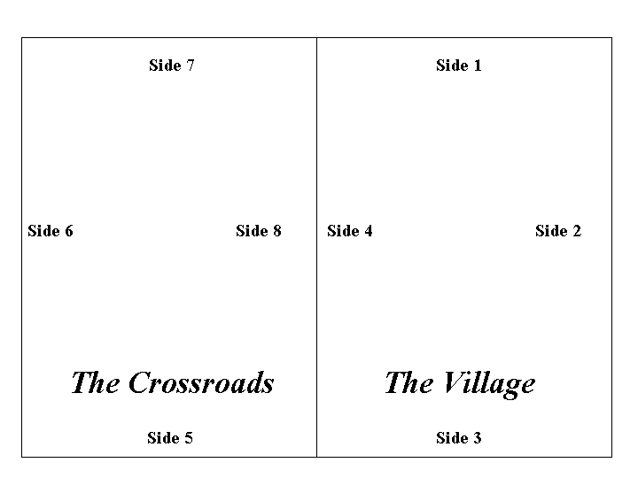

Setting the Scene
After the action on the previous day, the main “armies” clash at the village of Little Wooton.

The Sides

Sir Richard

Survivors from part one, plus:
Mounted Knights | Short Bows | Spears
Sir Richard | Fletcher | Bertin
Sir Conrad |  | Crispin
Sir Gaston | Bills | Hal
Sir John | Guy | Mark
Sir Piers | Jean | Odo
Sir Alain | Rees | Perkin
Sir William | Robin
 | Tybalt | Sergeant
 |  | Arnim

Sir Clugney
Survivors from part one, plus:
Mounted Knights | Crossbows | Halberds
Sir Clugney | Arbalister | Ben
Sir Gilbert |  | Frederick
Sir Jaques | Sergeant | Geoffrey
Sir Peter | Tyler | Hubert
Sir Roger |  | Naymes
Sir Roland |  | Otto
Sir Thomas |  | Tom
 |  | Watkin
 |  | Wynken

Starting Positions
- Playing pieces that ended the previous half of the scenario on the map must be set up first. If both players had pieces on the map, they must be placed in the same hexes in which they ended ‘The Villagers Choose’. If only one player has pieces on the map, he may place them anywhere he chooses.
- The players roll one die each. The remaining forces of the player with the higher roll (re-roll ties) enter the map on turn 1 from either side 5 or side 7 (his choice). This player takes his phase first in each game turn.
- On turn 1 (after the first player’s phase) the remaining forces of the second player enter the map from side 5 if the first player chose side 7, or side 7 if the first player chose side 5.

Victory Conditions

Play continues until all one side’s knights have been killed (in which case the other player wins) or one player concedes defeat.

